**Pintos project 0 보고서**

컴퓨터공학부

2013-11431 정현진

**1. System environment and execution problems and their solutions**

시스템 환경은 다음과 같다.

CPU: Intel® Core™ i7-4720HQ CPU @ 2.60GHz (8 CPUs), ~2.6GHz

RAM: 8192MB RAM

구동 환경: VMware player 12 가상머신을 이용해 Linux Mint 17.2 32-bit 운영체제를 사용.

처음 bochs와 pintos를 설치한 뒤 ‘make tests/threads/alarm-single.result’를 실행하는 과정에서 다음과 같이 “Run didn’t start up properly: no “Pintos booting” message” 이라는 메세지가 출력되며 에러가 발생하였다.



이 문제는 PPT에 있는 해결방식을 이용해 bochs가 설치되어 있는 폴더의 main.cc 파일에서 ‘bx_print_header()’ 라는 함수를 주석처리 해주어 문제를 해결하였다.

**2. Execution results of ‘alarm-multiple’**

‘alarm-multiple’의 실행 결과는 다음과 같다.

hyunjin@hyunjin-virtual-machine ~/Pintos/prj0/src/threads/build $ ../../utils/pintos -- -q run alarm-multiple  
Prototype mismatch: sub main::SIGVTALRM () vs none at ../../utils/pintos line 940.  
Constant subroutine SIGVTALRM redefined at ../../utils/pintos line 932.  
warning: can't find squish-pty, so terminal input will fail  
bochs -q  
00000000000i[      ] BXSHARE not set. using compile time default '/usr/local/share/bochs'  
00000000000i[      ] reading configuration from bochsrc.txt  
00000000000e[      ] bochsrc.txt:8: 'user_shortcut' will be replaced by new 'keyboard' option.  
00000000000i[      ] installing nogui module as the Bochs GUI  
00000000000i[      ] using log file bochsout.txt  
PiLo hda1  
Loading..........  
Kernel command line: -q run alarm-multiple  
Pintos booting with 4,096 kB RAM...  
383 pages available in kernel pool.  
383 pages available in user pool.  
Calibrating timer...  204,600 loops/s.  
Boot complete.  
Executing 'alarm-multiple':  
(alarm-multiple) begin  
(alarm-multiple) Creating 5 threads to sleep 7 times each.  
(alarm-multiple) Thread 0 sleeps 10 ticks each time,  
(alarm-multiple) thread 1 sleeps 20 ticks each time, and so on.  
(alarm-multiple) If successful, product of iteration count and  
(alarm-multiple) sleep duration will appear in nondescending order.  
(alarm-multiple) thread 0: duration=10, iteration=1, product=10  
(alarm-multiple) thread 0: duration=10, iteration=2, product=20  
(alarm-multiple) thread 1: duration=20, iteration=1, product=20  
(alarm-multiple) thread 2: duration=30, iteration=1, product=30  
(alarm-multiple) thread 0: duration=10, iteration=3, product=30  
(alarm-multiple) thread 3: duration=40, iteration=1, product=40  
(alarm-multiple) thread 0: duration=10, iteration=4, product=40  
(alarm-multiple) thread 1: duration=20, iteration=2, product=40  
(alarm-multiple) thread 4: duration=50, iteration=1, product=50  
(alarm-multiple) thread 0: duration=10, iteration=5, product=50  
(alarm-multiple) thread 0: duration=10, iteration=6, product=60  
(alarm-multiple) thread 1: duration=20, iteration=3, product=60  
(alarm-multiple) thread 2: duration=30, iteration=2, product=60  
(alarm-multiple) thread 0: duration=10, iteration=7, product=70  
(alarm-multiple) thread 3: duration=40, iteration=2, product=80  
(alarm-multiple) thread 1: duration=20, iteration=4, product=80  
(alarm-multiple) thread 2: duration=30, iteration=3, product=90  
(alarm-multiple) thread 4: duration=50, iteration=2, product=100  
(alarm-multiple) thread 1: duration=20, iteration=5, product=100  
(alarm-multiple) thread 2: duration=30, iteration=4, product=120  
(alarm-multiple) thread 3: duration=40, iteration=3, product=120  
(alarm-multiple) thread 1: duration=20, iteration=6, product=120  
(alarm-multiple) thread 1: duration=20, iteration=7, product=140  
(alarm-multiple) thread 2: duration=30, iteration=5, product=150  
(alarm-multiple) thread 4: duration=50, iteration=3, product=150  
(alarm-multiple) thread 3: duration=40, iteration=4, product=160  
(alarm-multiple) thread 2: duration=30, iteration=6, product=180  
(alarm-multiple) thread 3: duration=40, iteration=5, product=200  
(alarm-multiple) thread 4: duration=50, iteration=4, product=200  
(alarm-multiple) thread 2: duration=30, iteration=7, product=210  
(alarm-multiple) thread 3: duration=40, iteration=6, product=240  
(alarm-multiple) thread 4: duration=50, iteration=5, product=250  
(alarm-multiple) thread 3: duration=40, iteration=7, product=280  
(alarm-multiple) thread 4: duration=50, iteration=6, product=300  
(alarm-multiple) thread 4: duration=50, iteration=7, product=350  
(alarm-multiple) end  
Execution of 'alarm-multiple' complete.  
Timer: 889 ticks  
Thread: 55 idle ticks, 837 kernel ticks, 0 user ticks  
Console: 2951 characters output  
Keyboard: 0 keys pressed  
Powering off..========================================================================  
Bochs is exiting with the following message:  
[UNMAP ] Shutdown port: shutdown requested  
========================================================================

**3. Testing results of ‘alarm-multiple’**

make tests/threads/alarm-multiple.result를 수행한 결과는 다음과 같다.



그리고 tests/threads 폴더에 ‘alarm-multiple.result’라는 파일이 생성되었는데 내용은 다음과 같다.



테스트를 통과한 것을 볼 수 있었다.

**4. Execution results of the series of following commands during debugging**

gdb를 실행했더니 다음과 같이 1234번 포트와의 연결을 기다린다는 메시지가 출력되었다.

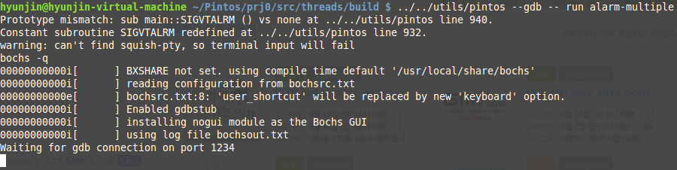

그 뒤 새로운 terminal을 열어 ‘pintos-gdb kernel.o’를 실행시키고 ‘target remote localhost:1234’ 명령어를 입력하니 기존의 터미널에서 1234 포트에 연결되었다는 메시지가 출력되었다.

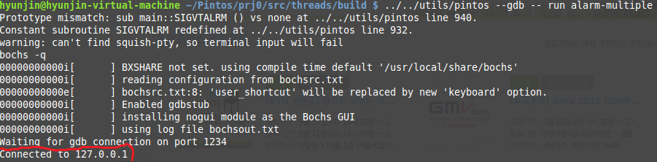

그 뒤 새로운 터미널의 gdb에서 지정된 명령어를 순서대로 입력한 결과는 다음과 같다.

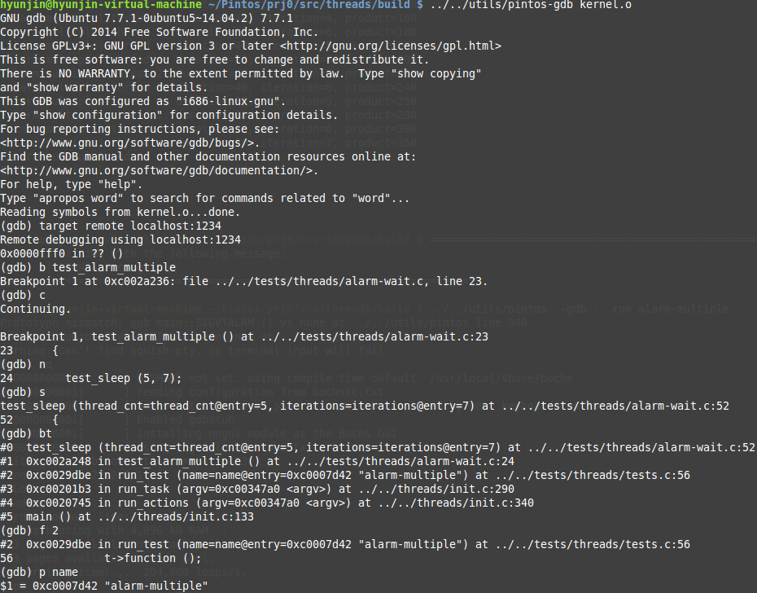

그 뒤 gdb를 종료하자 기존 terminal에 있던 bochs도 다음과 같은 메시지를 출력하며 종료되었다.

